**Project Documentation**

# COOKBOOK : YOUR VIRTUAL KITCHEN ASSISTANT

# 1. Introduction

* **Project Title:** Cookbook: Your Virtual Kitchen Assistant
* **Team ID** : NM2025TMID36527
* **Team Leader**: Jayasri M & 24csjayasri.m109@gmail.com
* **Team Members:**

- Veera Dhaya Dharani S & 24csveeradhayadharani110@gmail.com

- Ramoliya Y & 24csramoliya.y075@gmail.com

-Sandhiya S & 24cssandhiya084@gmail.com

-Subbulakshmi M & 24cssubbulakshmi97@gmail.com

# 2. Project Overview

* **Purpose:**. The CookBook application is designed to simplity meal preparation by offering a virtual kitchen assistant. Users can browse, save, and manage their favorite recipes with detailed instructions and ingredient lists
* **Features:**

- Extensive Recipe Library with Search & Filter Options

Step-by-Step Cooking Instructions

- Bookmark Feature for Favorite Recipes

- Light/Dark Mode for Enhanced Visual Comfort

- Responsive Design for Optimal Viewing on All Devices

# 3. Architecture

* **Frontend:** React.js with Bootstrap and Material UI
* **Backend:** Node.js and Express.js managing server logic and API endpoints
* **Database:** MongoDB stores user data, project information, applications, and chat messages

# 4. Setup Instructions

* **Prerequisites:**
* - Node.js (v18 or higher)
* - npm or yarn
* **Installation Steps:**
* 1. Clone the Repository: git clone https://github.com/darunraj0071/cookbook-app.git cd cookbook-app
* 2. Install Dependencies: npm install
* 3. Create env file:REACT_APP_RECIPE_API_KEY=your_api_key_here
* 4. Run the Application:

npm start

/src

/components

Header.js

RecipeList.js

RecipeCard.js

RecipeDetails.js

Footer.js

/pages

Home.js

Categories.js

Bookmarks.js

/assets

images

icons

styles

/utils

api.js

-helpers.js

constants.js

App.js

index.js

# 5. Folder Structure

SB-Works/

|-- client/ # React frontend

|__components/ L__ pages/

|__ server/ # Node.js backend

|__routes/

|__ models/

|__ controllers/

# 6. Running the Application

* **Frontend:**

cd client npm start • **Backend:**

cd server npm start

* **Access:** Visit http://localhost:3000

# 7. API Documentation

* **User:**
  + /api/user/register
  + /api/user/login
* **Projects:**
  + /api/projects/create
  + /api/projects/:id
  + • **Applications:** /api/apply
* **Chats:**
  + /api/chat/send **–** /api/chat/:userId

# 8. Authentication

* JWT-based authentication for secure login
* Middleware protects private routes

# 9. User Interface

Clean and intuitive layout optimized for smooth navigation

-Mobile-first design for seamless browsing

- Elegant Light/Dark mode toggle for improved accessibility

# 10. Testing

**Testing Strategy:**

Jest for unit testing

React Testing Library for component testing

Code Coverage: Ensured high test coverage with jest reports

1. **Screenshots or Demo**

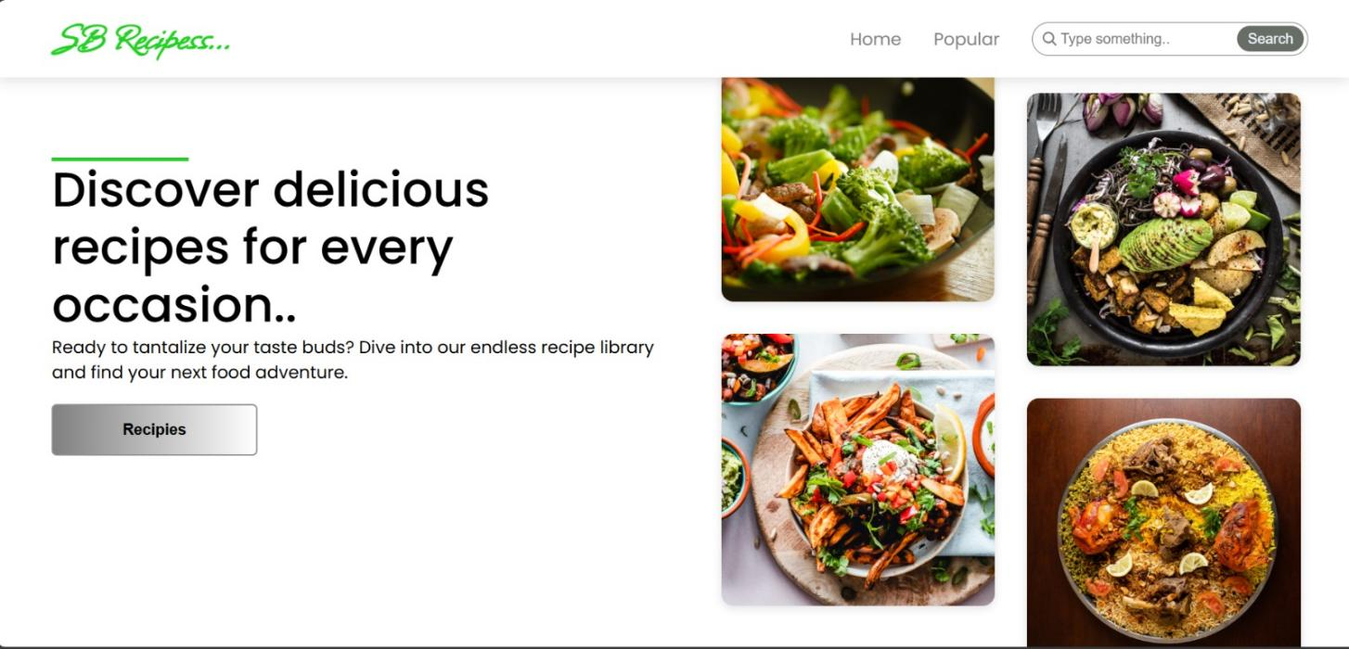

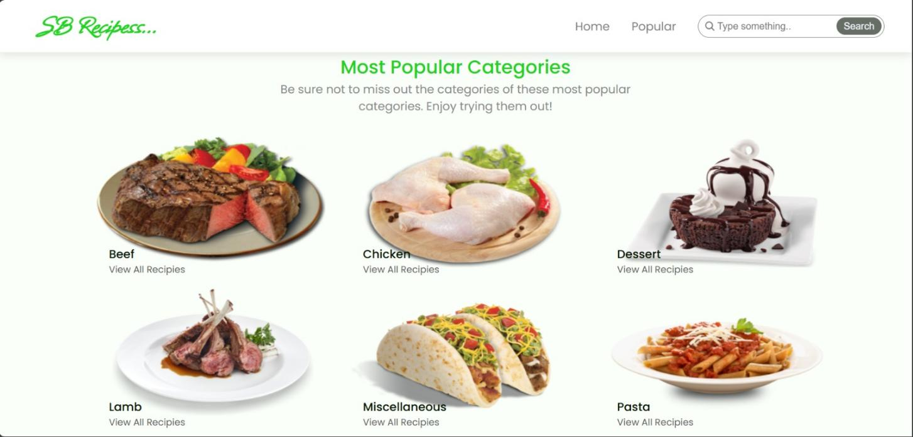

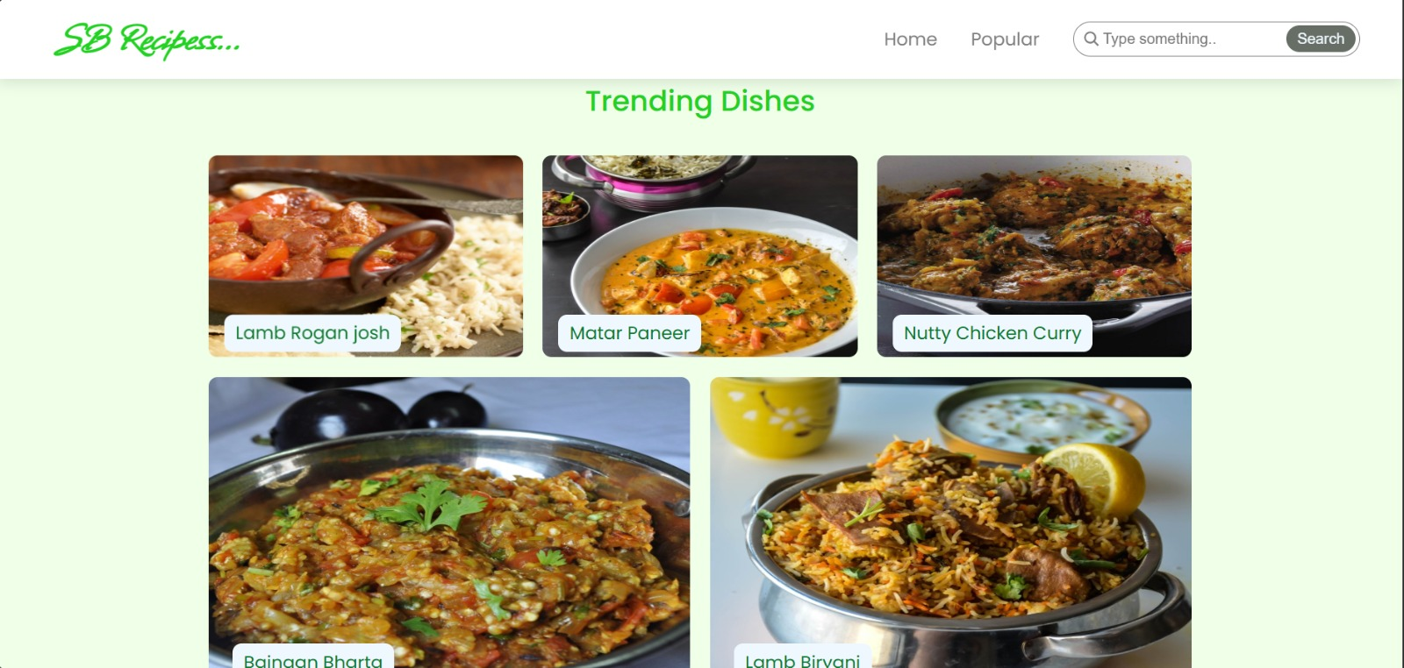

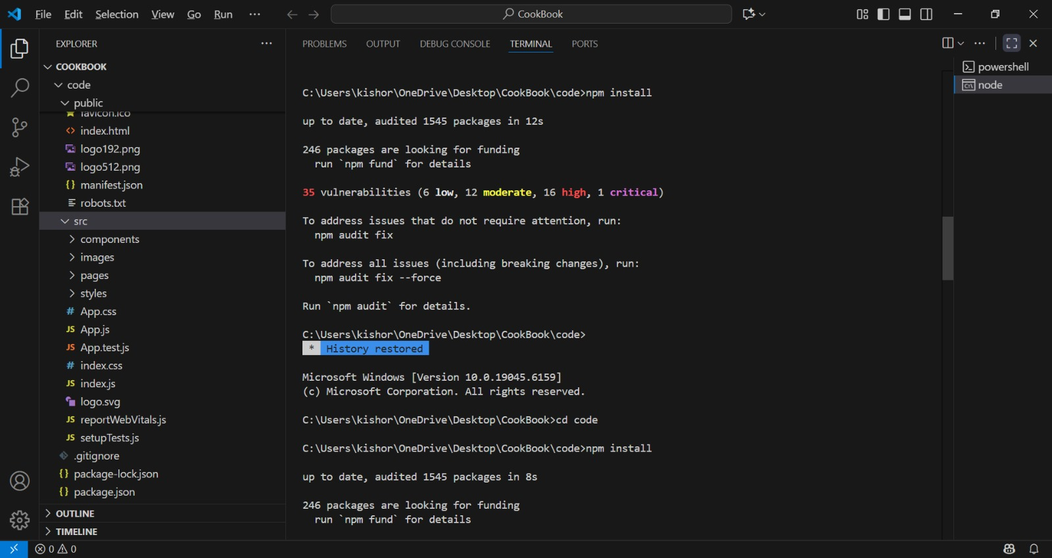











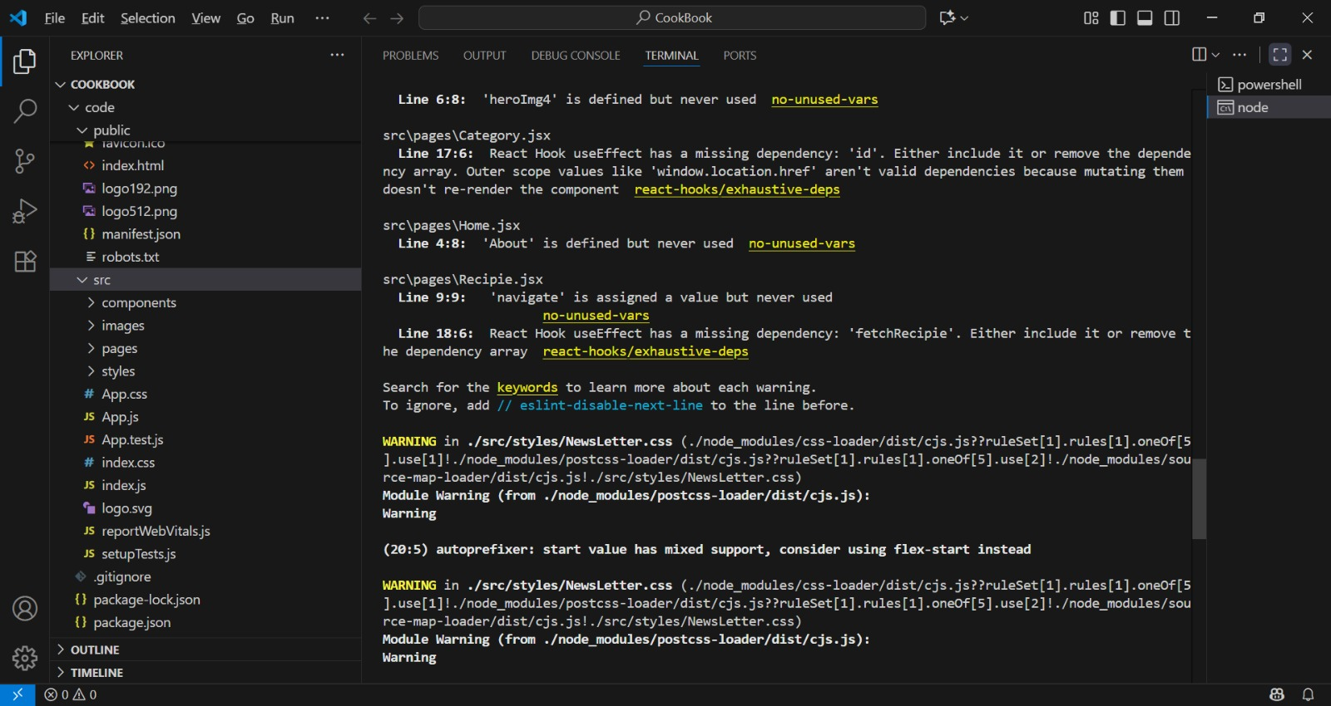

1. **Known Issues**

-Certain API endpoints may experience delays during peak traffic

- Ingredient checklist feature may require further optimization**.**

# 13. Future Enhancements

-Al-Based Recipe Suggestions

-User Authentication for personalized recipe collections

-Integration with Grocery Shopping Platforms

-Offline Mode for accessing saved recipes